Task P - 1.2

ML Development using Python

Saurabh Dharmadhikari

Saurabh.dharma01@gmail.com

Survival prediction on

Titanic dataset

|  |  |
| --- | --- |
| Question 1. **What is the selected dataset and what is related problem for this dataset? You need to provide details of datasets, dataset description, what are the features, output (class label) and discuss the problem needs to be solved by machine learning model. (Minimum 200 words)** | 2 |
| Question 2. **You need to provide the screenshot of the built ML pipeline (Data ingestion, Data preparation, model training and evaluating the model). You need to provide explanation for cell by cell of the code.** | 3 |
| Question 3. **What is the performance of the build model/ models? You need to provide discussion and justification of how the model is performing (discuss different matrices, accuracy confusion matrix) based on the selected dataset.** | 13 |
| Question 4. **You need to compare the performance of the models and provide justifications which mode is performing better and why** | 14 |

Table of Content:

1. **What is the selected dataset and what is related problem for this dataset? You need to provide details of datasets, dataset description, what are the features, output (class label) and discuss the problem needs to be solved by machine learning model. (Minimum 200 words)**

The Titanic dataset is one of the most famous datasets used in machine learning. It is based on the passengers who were aboard the RMS Titanic during its maiden voyage that sank on April 15, 1912. The dataset contains information on 891 of the 2,224 passengers and crew members.

The dataset includes various attributes such as age, gender, class, fare, cabin, ticket number, and embarkation port, among others. The target variable in this dataset is survival, which indicates whether a passenger survived the disaster or not. This makes it a binary classification problem where the aim is to predict whether a passenger survived or not based on the given features.

Some of the features in the dataset contain missing values, making data pre-processing an essential part of this task. We have used the dataset to build decision tree and random forest to predict survivors and attributes contributing to it.

## Sample dataset:

|  | **pclass** | **survived** | **name** | **sex** | **age** | **sibsp** | **parch** | **ticket** | **fare** | **cabin** | **embarked** | **boat** | **body** | **home.dest** |
| --- | --- | --- | --- | --- | --- | --- | --- | --- | --- | --- | --- | --- | --- | --- |
| **0** | 1.0 | 1.0 | Allen, Miss. Elisabeth Walton | female | 29.0000 | 0.0 | 0.0 | 24160 | 211.3375 | B5 | S | 2 | NaN | St Louis, MO |
| **1** | 1.0 | 1.0 | Allison, Master. Hudson Trevor | male | 0.9167 | 1.0 | 2.0 | 113781 | 151.5500 | C22 C26 | S | 11 | NaN | Montreal, PQ / Chesterville, ON |
| **2** | 1.0 | 0.0 | Allison, Miss. Helen Loraine | female | 2.0000 | 1.0 | 2.0 | 113781 | 151.5500 | C22 C26 | S | NaN | NaN | Montreal, PQ / Chesterville, ON |
| **3** | 1.0 | 0.0 | Allison, Mr. Hudson Joshua Creighton | male | 30.0000 | 1.0 | 2.0 | 113781 | 151.5500 | C22 C26 | S | NaN | 135.0 | Montreal, PQ / Chesterville, ON |
| **4** | 1.0 | 0.0 | Allison, Mrs. Hudson J C (Bessie Waldo Daniels) | female | 25.0000 | 1.0 | 2.0 | 113781 | 151.5500 | C22 C26 | S | NaN | NaN | Montreal, PQ / Chesterville, ON |

## Data Description:

|  | **pclass** | **survived** | **age** | **sibsp** | **parch** | **fare** | **body** |
| --- | --- | --- | --- | --- | --- | --- | --- |
| **count** | 1309.000000 | 1309.000000 | 1046.000000 | 1309.000000 | 1309.000000 | 1308.000000 | 121.000000 |
| **mean** | 2.294882 | 0.381971 | 29.881135 | 0.498854 | 0.385027 | 33.295479 | 160.809917 |
| **std** | 0.837836 | 0.486055 | 14.413500 | 1.041658 | 0.865560 | 51.758668 | 97.696922 |
| **min** | 1.000000 | 0.000000 | 0.166700 | 0.000000 | 0.000000 | 0.000000 | 1.000000 |
| **25%** | 2.000000 | 0.000000 | 21.000000 | 0.000000 | 0.000000 | 7.895800 | 72.000000 |
| **50%** | 3.000000 | 0.000000 | 28.000000 | 0.000000 | 0.000000 | 14.454200 | 155.000000 |
| **75%** | 3.000000 | 1.000000 | 39.000000 | 1.000000 | 0.000000 | 31.275000 | 256.000000 |
| **max** | 3.000000 | 1.000000 | 80.000000 | 8.000000 | 9.000000 | 512.329200 | 328.000000 |

We can easily see from the above table different statistical value of features in the dataset. Average age of people on board is 29. Average fare of the voyage is 33 with maximum being 512. Other such helpful statistical values can be seen above.

1. **You need to provide the screenshot of the built ML pipeline (Data ingestion, Data preparation, model training and evaluating the model). You need to provide explanation for cell by cell of the code.**

## Data Ingestion:

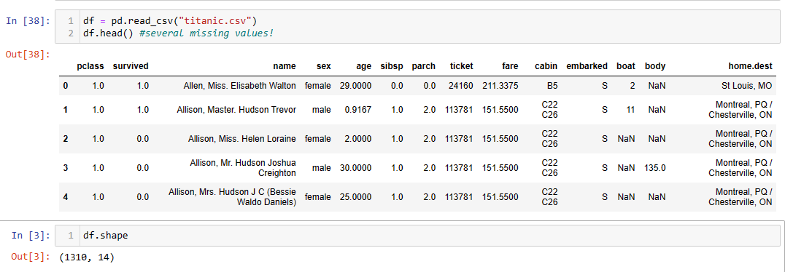

We uploaded the dataset provided.

## Data preparation:

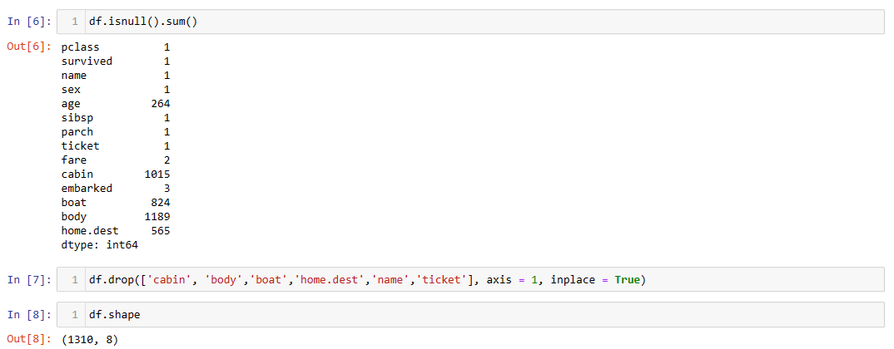

Here we can see that there are a lot of missing values, especially in features like cabin, boat, body, home.dest and age. So we have dropped cabin, body, home.dest, name and ticket. So we are left with 8 features.

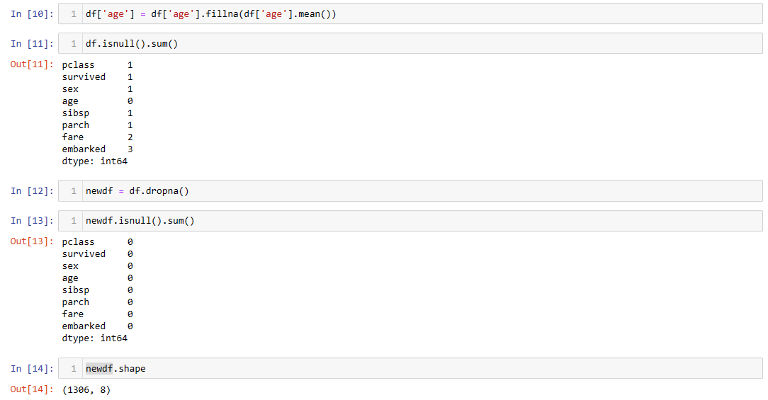

For feature age we filled the null values with mean value. We also removed a few rows which had null values in other features of this dataset. Now we are left with 1306 rows and 8 features.

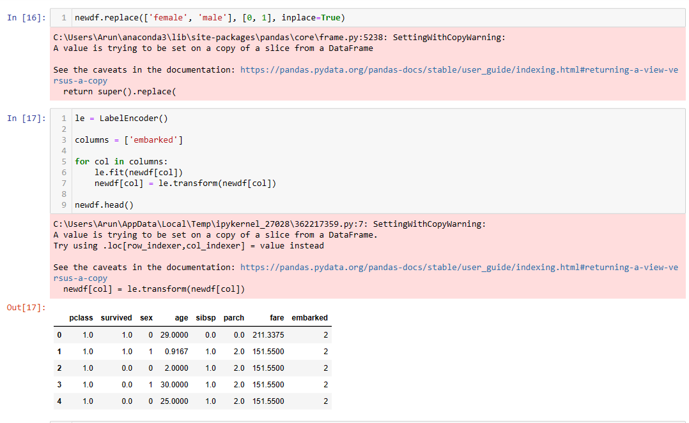

We replaced female with 0 and male with 1 in the sex column and used label encoding for embark feature. Thus, we have all the features in numeric form and is ready to be used in decision tree.

Let us first do some exploratory data analysis just before that as now we have data prepared.

There are no outliers in feature pclass:

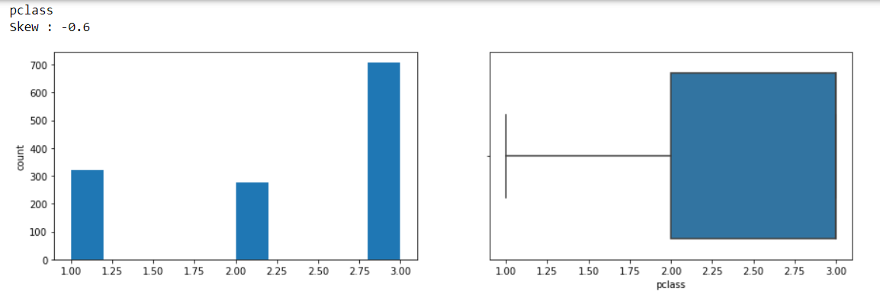

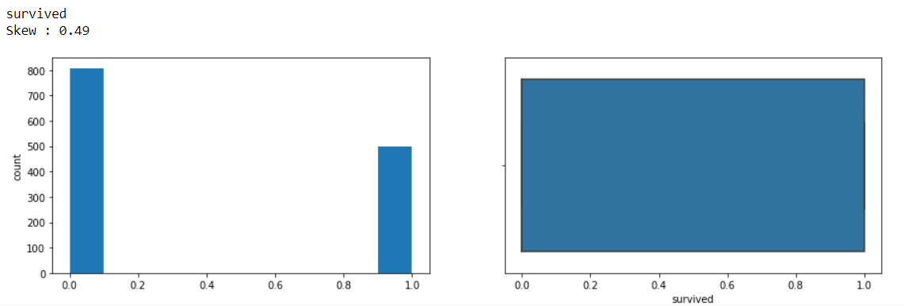

From the above bar chart, we can see that almost 800 people could not survive from the sample set that we have taken and close to 450 people survived the titanic disaster.

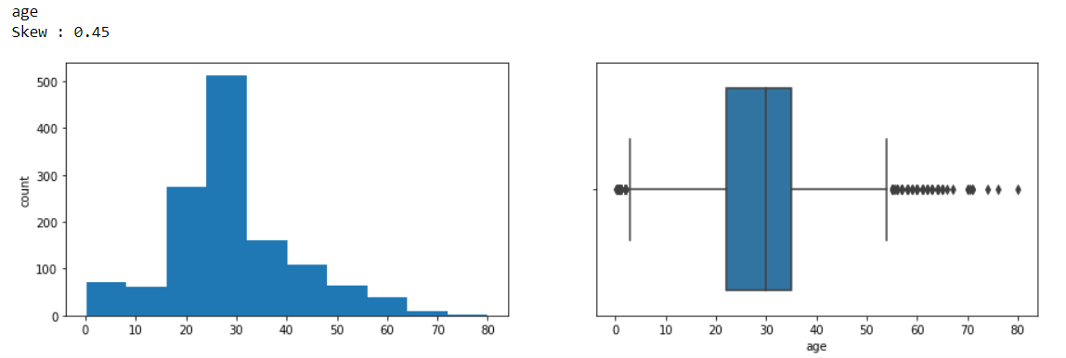

In the above box plot we see that there are numerous outliers in feature age but none of them are uncommon so we will presume that the information collected is correct and good to go with. Through bar chart we observe that most people boarding the ship were from the age group of 25 to 30.

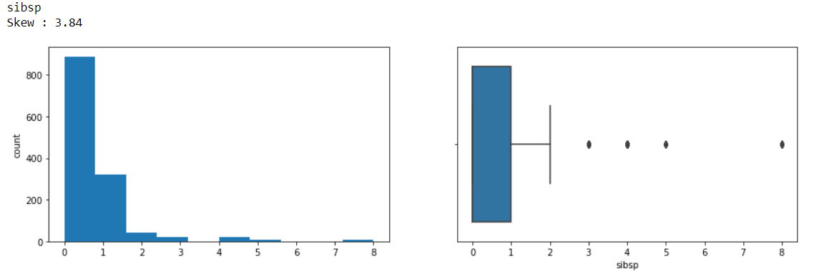

Sibling or spouse aboard feature shows most passengers did not have any siblings or spouse travelling with them. There are also a few outliers with maximum number being 8.

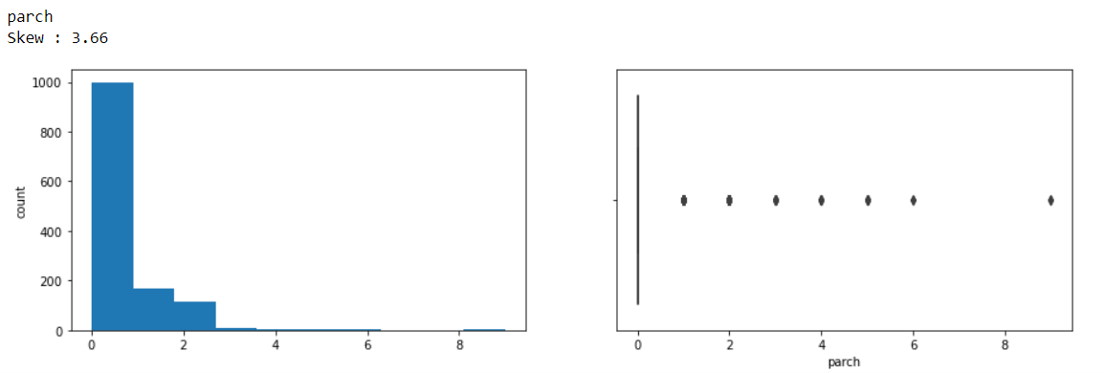

Above feature shows us that chances of parents or children travelling with a passenger is very low. Again, there are a few outliers with maximum as 9.

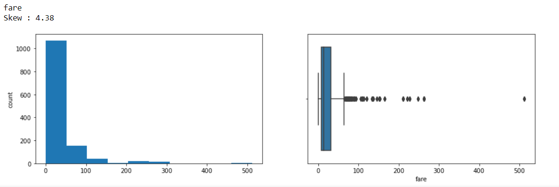

Fare on an average is 33 for one passenger with a minimum of 0 going up to around 500 in British currency, which is an outlier.

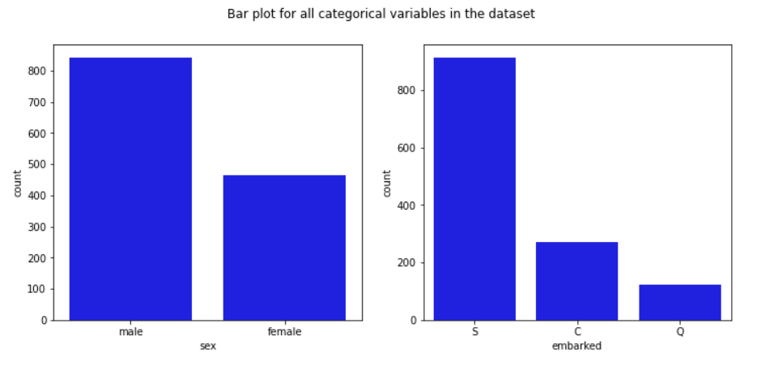

We can now see here that number of males in our sample dataset is more than female with about 850 whereas females count about 450. Also on the right in the above bar chart we find most people started their journey from Southampton(850), about 240 from Cherbourg and about 100 from Queenstown.

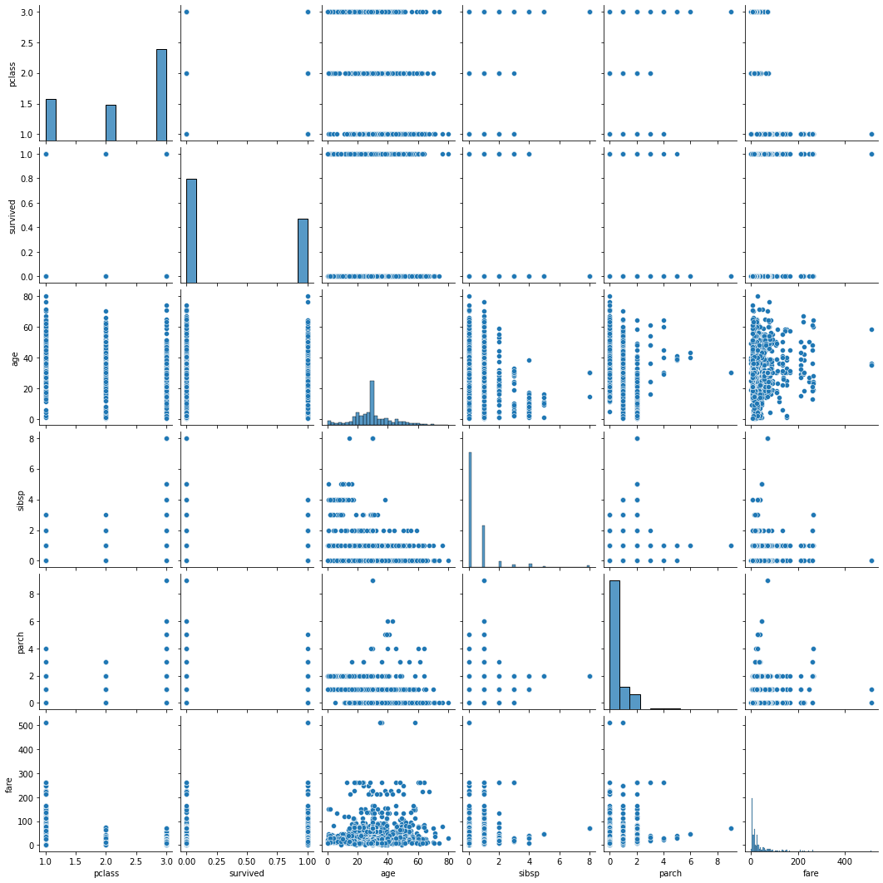

Above is a scatter plot for the prepared dataset.

Age and survived scatter plot equally distributed.

We do not find much linear pattern in the scatter plots we created.

Let us see the correlation heatmap for better understanding:

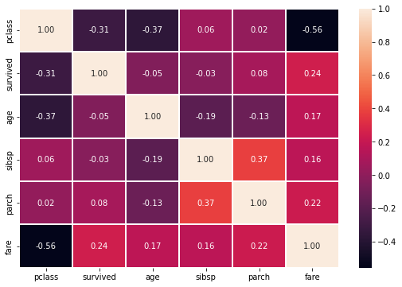

Here we are able to see that pclass and fare has a good negative correlation. Otherwise we do not have a very good correlation between features.

Let us now move ahead and split data to train and test to build and test our models:

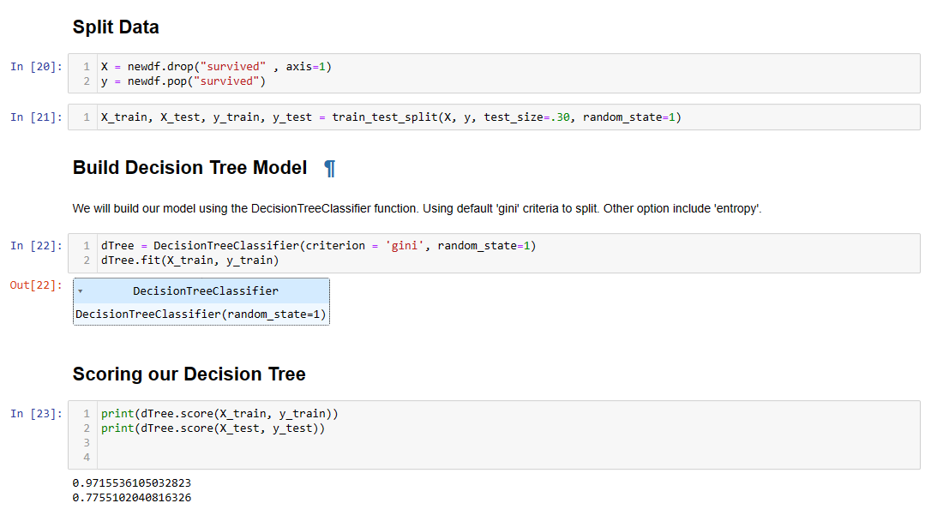

We split our data in 70:30 ratio. Used gini criterion and built our decision tree. We got a score of 97.1% on train set and 77.5% score on our test set. Thus, this model looks to be over fit.

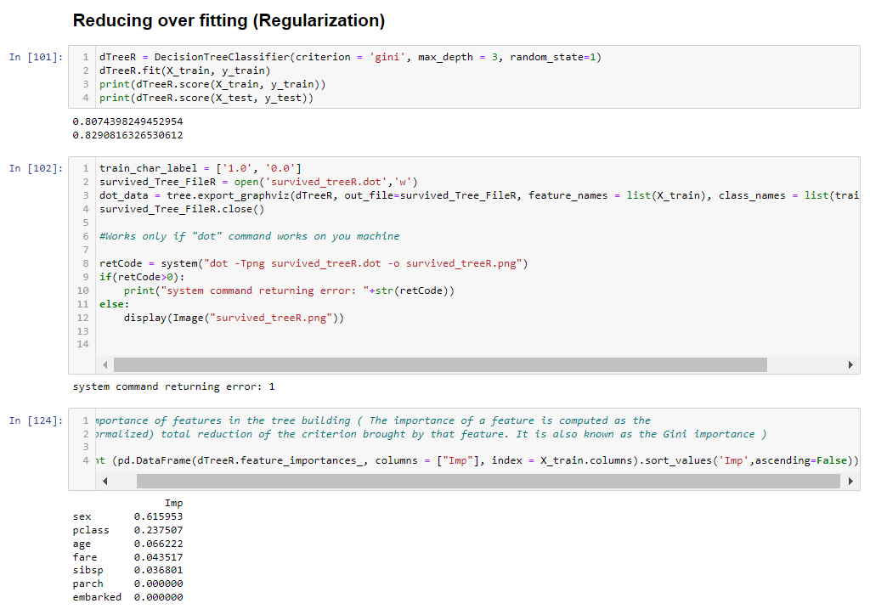

We then regularised the data by pruning giving a max depth of 3. We now see that scores have improved for the test set with 82.9%.

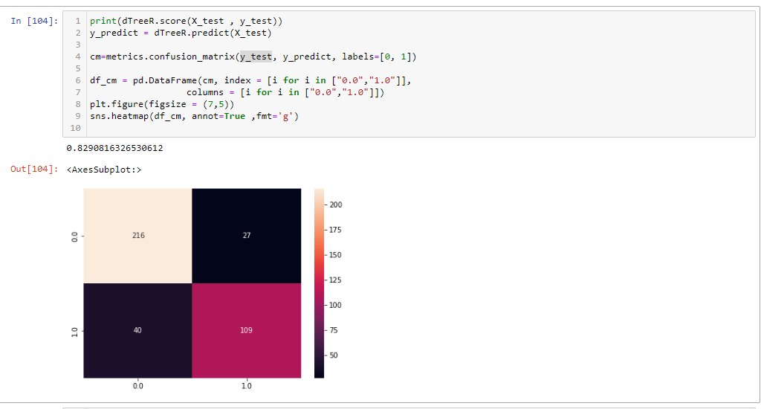

Above is the confusion matrix for the model built.

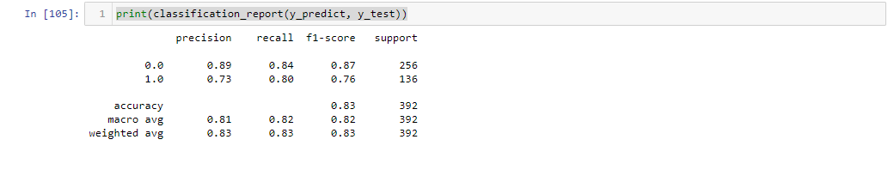

Above we see a precision for survived is 73 and recall is 80, with an accuracy of 83.

The model looks good.

Let us try to build more models and see.

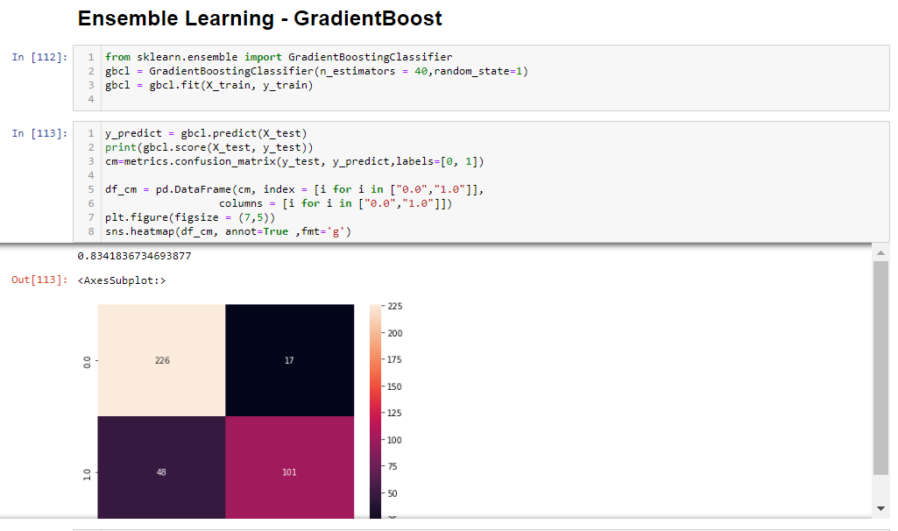

We used ensemble learning with gradient boost to give us better results with a score of 83.4%.

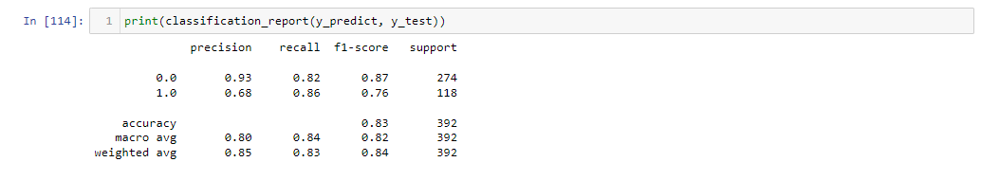

In gradient boost we get a precision of survived of only 63 and recall is 86. But we need a much-balanced model.

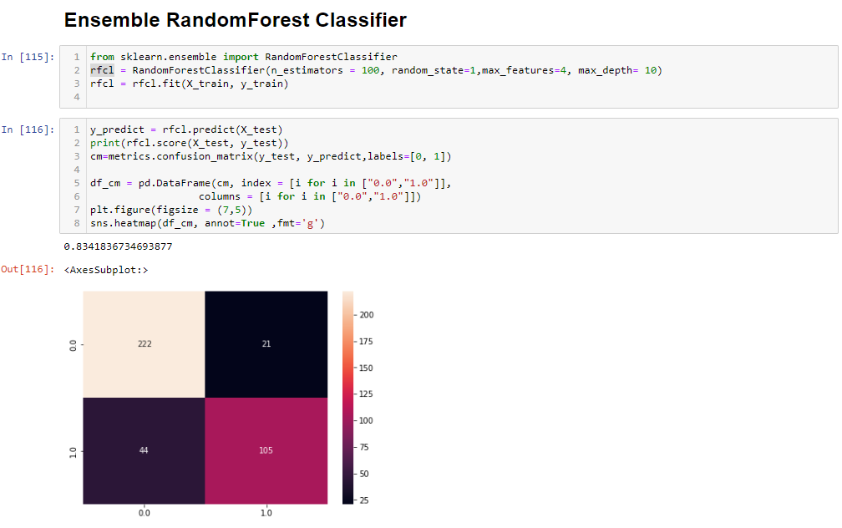

We deployed random forest on the test set and we got a score of 83.4%.

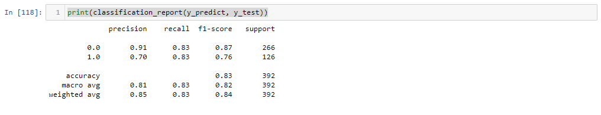

Here we find a precision of 70 and recall of 83.

1. **What is the performance of the build model/ models? You need to provide discussion and justification of how the model is performing (discuss different matrices, accuracy confusion matrix) based on the selected dataset.**

We may say that the performance of random forest the best compared to other models.

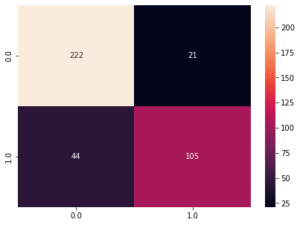

With an accuracy score of 83.4. It has predicted correctly that 222 passengers did not survive, who actually could not survive and predicted 105 passengers survived, who actually survived. But it also has predicted incorrectly 21 people survive who actually did not survived and 44 people did not survive but actually survived.

1. **You need to compare the performance of the models and provide justifications which mode is performing better and why.**

Decision tree using gradient boost is the best model that we were able to form as it gives us the best accuracy of 83.1.

We will also be more interested in recall to be higher as in a real case scenario of a disaster we would want to know how many predicted survived have actually survived and efforts will be to save as many as we can.

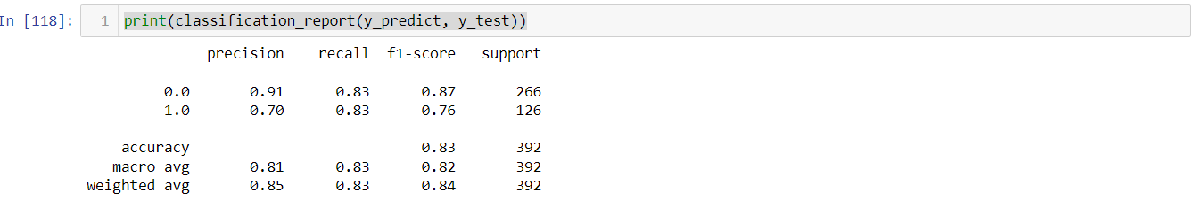

This model again gives us the best recall when compared to other models that we have developed.

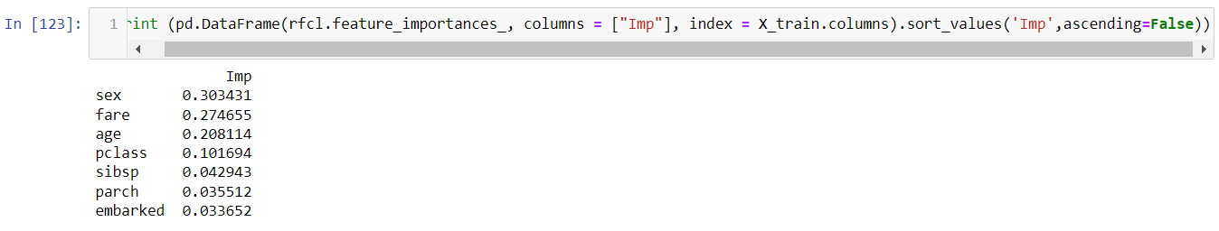

The most important features for prediction according to random forest are in above table in descending order. The most important feature is sex, followed by fare and then age. These three features collectively are almost 77% important for predictions.